**Handbook for FIMAS**

1. Starting software

After you have extracted the compressed FIMAS file you have downloaded, all programme files should remain in their file structures. Open ./bin/FIMAS.m in your Matlab windows and run the programme either by press Run button or in the command windows type in FIMAS and press RETURN. This should start the FIMAS main interface as illustrated below.

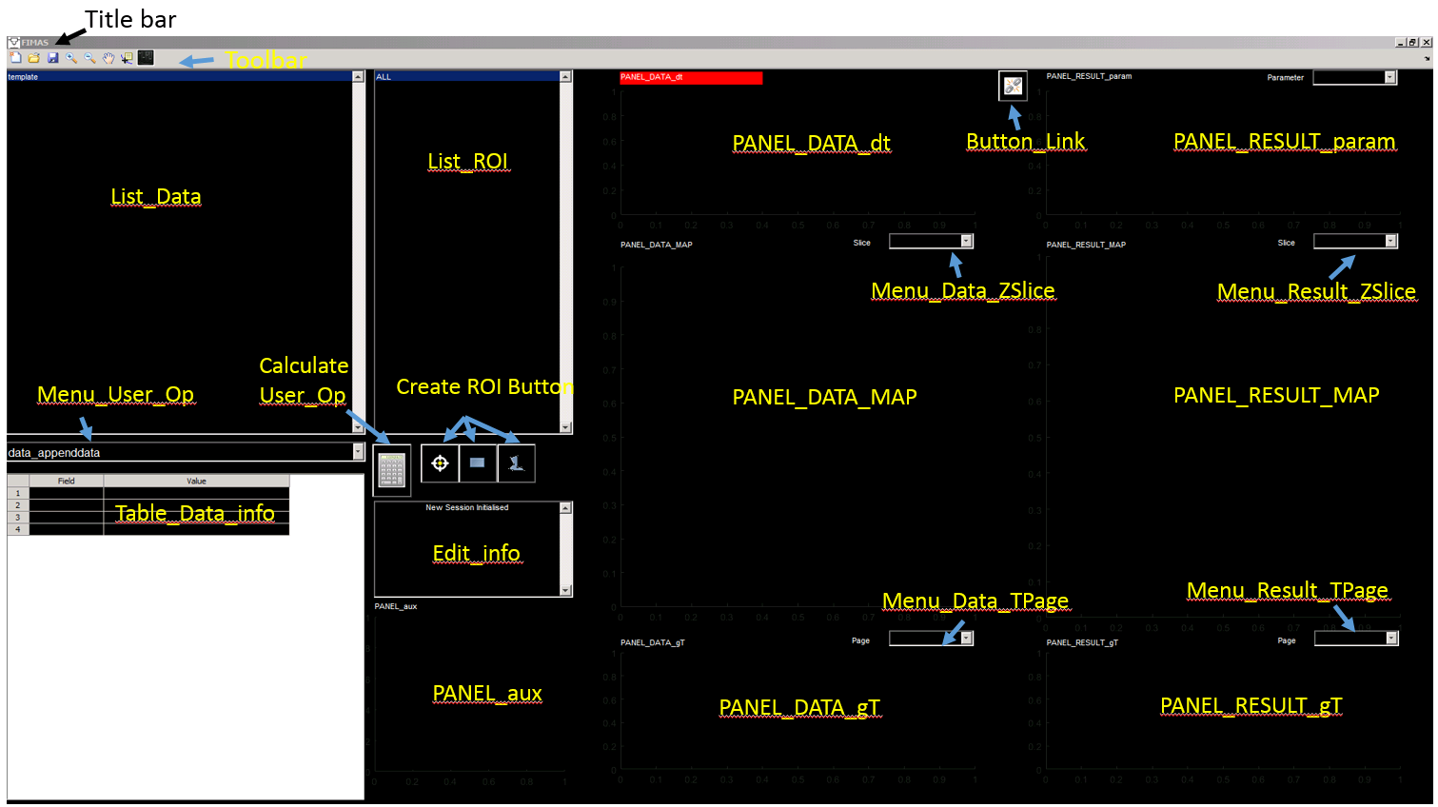

1. Import data files
2. Export data item
3. Open saved FIMAS data file
4. Save FIMAS data file
5. Start new session
6. Display data item metadata information
7. Delete data item
8. Display data item
9. Edit data item data information
10. Create ROI
11. ROI related functions
12. User Operation
13. Graph control
14. GUI Graph Control